pattern

<PATIENT-ADDRESS>

<DATE>

Information for Patients: Therapeutic Apheresis / Toxopherese®

Dear Sir or Madam,

Therapeutic Apheresis / Toxopherese® is an innovative component of the our detox concept. Based on 6,000 years of experience of blood-letting therapists from all cultures of the world, the present treatment form is a special form of high-technology plasma purification and immune modulation in case of chronic and acute diseases of metabolism and the immune system (so-called autoimmune diseases).

The blood plasma purification, also called plasmapheresis (derived from the Greek word apherein = to separate), helps the body to free itself of harmful proteins and metabolic products (e.g. cholesterol, and many more) or other loads (so-called paraproteins, circulating immune complexes, complex infectious toxins, pathoproteins, haptens), and bring the disregulated metabolism / the inflammatory cascade or the immune system back to its natural balance (a so-called metabolic/immune modulation). Thus, the innate self-healing powers of the organism are re-activated.

The apheresis performed by us IS NOT A PLASMA EXCHANGE. Therefore, it does not have the side effects of such a treatment. No electrolytes or other healthy components but only pathogenic loads are filtered out.

Thus, therapeutic apheresis is a component of modern holistic medicine.

What is the procedure of Therapeutic Apheresis / Toxopherese®?

In our <PRACTICE NAME>, we use the ultra-modern technology of membrane filtration apheresis, which has been developed in Japan since 1980. Tailored to the “molecular pattern” of the patient, so-called differential filters are used as “intelligent” molecular sieves. At present, a total of 5 types of these differential filters exist.

The blood is withdrawn and returned through the arm veins by means of special cannulae. A treatment takes approx. 2 hours. The treatment is performed by a specially trained medical team of the <PRACTICE NAME> (specially trained and certified nurses). The determination of the indication, as well as the supervision and carrying out of the treatment are the responsibility of <DOCTOR>, an internist who has undergone a special training in nephrology, hypertension and autoimmun diseases over years and in therapeutic apheresis with main focus on nephrology/hypertensiology (the science of renal and hypertension diseases and blood purification procedures).

Therapeutic Apheresis international

Apheresis is not a specific therapy form of German medicine but part of the world-wide knowledge of the nowadays globalized medicine.

At present, there are 17 national apheresis associations, as well as 3 international apheresis associations:

the World Apheresis Association (WAA), the International Society for Therapeutic Apheresis (ISFA), and the European Society for Haemapheresis.

The biggest national apheresis associations are in India and Japan.

Germany does not have a special association for therapeutic apheresis. Its tasks are assumed by the German Society for Clinical Nephrology (Deutsche Arbeitsgemeinschaft Klinische Nephrologie e.V.) (www.nephrologie.de).

What Types of Therapeutic Apheresis exist?

There are the following types of therapeutic apheresis:

• Filtration apheresis (membrane differential filtration apheresis) (see diagram)
• Adsorption apheresis (antibodies, immune adsorption) (see diagram)
• Billirubin adsorption apheresis
• Whole blood / cell sorption apheresis (DALI / cell sorption) (see diagram)

The apheresis unit of the <PRACTICE NAME> provides the following types of therapeutic apheresis:

- Filtration apheresis
- Adsorption apheresis
- Cell sorption apheresis
pattern

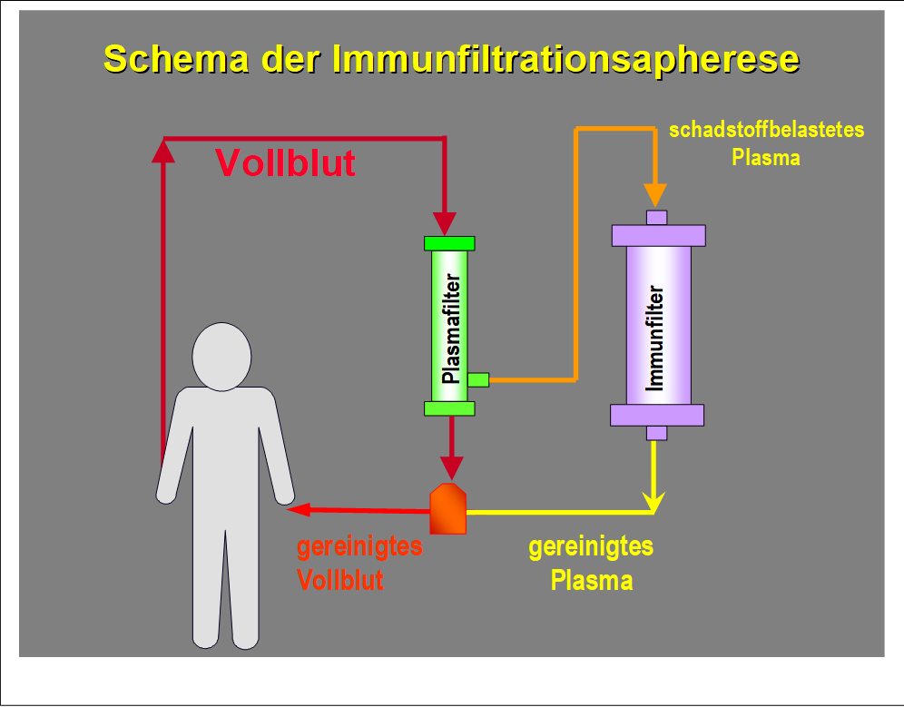
pattern

Schema der Immunfiltrationsapherese = Schematic Diagram of Immun Filtration Apheresis

Vollblut = whole blood

Plasmafilter = plasma filter

gereinigtes Vollblut = cleaned whole blood

schadstoffbelastetes Plasma = polluted plasma

Differentialfilter = differential filter

gereinigtes Plasma = cleaned plasma

Which diseases can be treated with Plasmapherese?

Below, you will find the indications that - according to the present state of medical knowledge - can be treated by the above-mentioned apheresis procedures and have been documented and examined in studies / collections of case histories (e.g. the Apheresis Standard of the German Society for Clinical Nephrology). In this context, the rules of evidence-based medicine (EBM) are applied.

<PRACTICE NAME> has an international orientation. Therefore, it reserves the right to use also the guidelines and recommendations of other, international apheresis associations (e.g. Japanese Society for Apheresis, American Society for Apheresis, World Apheresis Association, International Society for Therapeutic Apheresis, guidelines of the US Food and Drug Administration (FDA), and others) as reference when determining indications and answering apheresis therapy related questions.

See list of indications in appendix 1.

Innovative indications for Therapeutic Apheresis / Toxopherese®

These indications are to be understood as last resort treatment attempts within our clinical concept if no other possibilities of conventional medicine and/or naturopathy are effective or known or/and if conventional treatment strategies (= pharmacotherapy, chemotherapy) are associated with severe side effects that can no longer be justified. The apheresis type used is filtration apheresis. Due to the collection of the filtered-out plasma residues, it is the only apheresis procedure that enables us to conduct further biochemical analyses that can clarify the background of the disease and lead to a holistic pathogenetic treatment approach. The obtained data are collected in a database, evaluated, and published internationally. Thus, they become a part of evidence-based medicine.

Innovative international indications:

• Alzheimer dementia syndrome

• Contamination with heavy metals, solvents and other environmental toxins leading to severe
disease patterns in the field of autoimmune diseases and/or other nervous diseases and/or skin diseases (e.g. fibromyalgia, blistering skin diseases, toxic nerve damage, renal damage, MCS,
CFS, Ciguatera intoxication).
pattern

• Lyme disease as late Lyme disease with severe progression of the disease that cannot be
treated with conventional means anymore (CFS / Guillain-Barré syndrome refractory to immune globulin therapy / severe therapy-refractory autoimmune diseases like rheumatism, systemic
collagenoses, lupus diseases, cardiomyopathies caused by detected autoantibodies against the heart in case of Lyme disease).

• Chronic fatigue syndrome (CFS)

• Chronic Hepatitis C (in Japan, the treatment is covered by the health insurance companies)

• EPH gestosis (EPH = edema, proteinuria, hypertension) – a severe disease during pregnancy
caused by specific antibodies that are directed against the placenta vessels and the vascular
system of the mother.

• Fibromyalgia syndrome

• Arterial hypertension - positive detection of alpha 1 and/or angiotensin 1 antibodies – cannot be treated at all or only with difficulty with conventional pharmacotherapy

• Multiple sclerosis (based on available data of the Canadian Apheresis Group)

• Multiple chemical hypersensitivity syndrome (MCS)

• Hyperbilirubinaemias in case of severe congenital metabolic diseases of the liver with
impending brain damage.

Appendix 1:
Indications for therapeutic apheresis at <Praxisname>
(in alphabetic order)

• Age-related macular degeneration - dry form
• Blood disease (haemophilia) if antibodies against factor V are detected
• Cardiolipin syndrome
• Chronic inflammatory demyelinating polyneuropathy (CIDP)
• Ulcerative colitis failure of chemotherapy and / or threatened surgical bowel removal
• Dermatomyositis - failure and / or severe side effects of chemotherapy
• Diabetic foot syndrome with impending amputation of the limbs if the conservative and
conventional ones fail surgical therapy
• Dilated cardiomyopathy - beta receptor antibody positive detection
• Eaton-Lambert syndrome (tumor-associated nerve disorder)
• Encephalitis disseminata (multiple sclerosis) - failure of interleukin-alpha therapy or antibody
formation against therapeutic interleukin with a progressive course
• Erdheim-Chester syndrome (with proof of paraprotein)
• Familial heterocygous hypercholesterolemia with failure / NW of conservative therapy and / or
premature and progressive arteriosclerosis / myocardial infarction / stroke / involvement of the
kidney vessels
• Familial homocygous hypercholesterolemia
• Focal sclerosing glomerulonephritis of the own kidneys or after kidney transplantation with
nephrotic syndrome and / or severe hypertriglyceridemia with failure of chemotherapy /
cholesterol synthesis inhibitor therapy and more rapidly increase in renal failure (loss of kidney
pattern
function)
• Glomerulonephritis (inflammatory kidney disease) pathogenetically directed - failure and / or
severe Chemotherapy side effects
• Guillain Barré Syndrome - chronic form / acute form
• Haemophilia (blood disease) if antibodies against factor V are detected
• Inhibitor hemophilia (tendency to bleed) if factor V antibodies are detected
• Gestational herpes
• sudden hearing loss (pathogenetically guided)
• Hypertriglyceridaemia (severe) with pancreatitis (inflammation of the pancreas)
• Hyperviscosity syndrome in plasmocytomas (multiple myeloma) and Waldenström's disease
• IgM-associated polyneuropathy (tumor-associated nerve disorder)
• Isolated familial Lp (a) hyperlipoproteinemia with premature arteriosclerosis / myocardial
infarction / stroke / involvement of the renal vessels / inoperable arterial occlusive disease of
the legs
• Cryoglobulinemic vasculitis (autoimmune blood vessel inflammation caused by cold proteins)
• Linear IgA dermatosis
• LA awareness in kidney transplantation
• Lupus erythematosus in the case of failure / severe side effects of chemotherapy
• Lupus erythematosus with progressive kidney involvement (glomerulonephritis)
• Macular degeneration (adult form) - dry form
• Miller-Fisher syndrome (tumor-associated nerve disorder)
• Behcet's disease - failure and / or severe side effects of chemotherapy
• Raynaud's disease - failure of conservative therapy
• Refsum's disease (storage disease)
• Waldenström's disease - benign IgM gammopathy with hyperviscosity
• Wegener's disease with kidney involvement and / or failure of chemotherapy (MEPEX study)
• Multiple sclerosis (see also Encephalitis disseminata)
• necrobiotic xanthogranulomatosis (with paraprotein)
• Nephrotic syndrome in inflammatory kidney disease (glomerulonephritis) pathogenetically
guided - failure and / or severe side effects of chemotherapy
• Pemphigus foliaceus failure and / or severe chemotherapy side effects
• Pemphigus vulgaris failure and / or severe side effects of chemotherapy
• Peripheral arterial occlusive disease (pathogenetically directed) in the event of failure of the
conservative and conventional surgical therapy options and impending limb loss
• Plasmocytoma with hyperviscosity syndrome / kidney involvement
• Polymyositis - failure and / or severe side effects of chemotherapy
• Psoriasis (most severe flare-ups with severe psoriatic arthritis) failure and / or severe side
effects of the chemotherapy
• Retinopathia pigmentosa in Refsum's disease
• Rheumatoid arthritis - when chemotherapy fails and extreme progression
• Sjogren's syndrome - failure and / or severe side effects of chemotherapy
• Progressive systemic scleroderma with kidney involvement (glomerulonephritis)
• Arndt-Gottron scleromyxedema - with kidney involvement and evidence of paraprotein - failure
and / or severe Chemotherapy side effects
• Stiff-man syndrome
• Transplant vasculopathy after heart transplantation
• Xanthogranulomatosis (necrobiotic) with paraprotein
pattern

